***Different Testing Techniques***

1. ***BVA (Boundary Value Analysis)***

For example, if you are designing a program to accept strings between 5 to 20 characters long, then the boundary values will be 5 and 20. To test this program for boundary value analysis, you should use strings that are 4, 5, 6, 19, and 20 characters long.

1. ***EP( Equivalence Partitioning Techniqu***e)

For example, a login form with an email field. Through equivalence partitioning, we can divide the possible input values into equivalence classes such as valid email addresses, invalid email formats, and empty fields.

1. ***Decision table:***

|  |  |  |  |  |
| --- | --- | --- | --- | --- |
| **Conditions** | **Rule 1** | **Rule 2** | **Rule 3** | **Rule 4** |
| **Username (T/F)** | F | T | F | T |
| **Password (T/F)** | F | F | T | T |
| **Output (E/H)** | E | E | E | H |

**Legend:**

* **T** – Correct username/password
* **F** – Wrong username/password
* **E** – Error message is displayed
* **H** – Home screen is displayed
* Enter the correct username and correct password and click on login, and the expected result will be the user should be navigated to the homepage
* Enter wrong username and wrong password and click on login, and the expected result will be the user should get an error message
* Enter correct username and wrong password and click on login, and the expected result will be the user should get an error message
* Enter wrong username and correct password and click on login, and the expected result will be the user should get an error message

1. ***State Transition:***

An ATM system function where if the user enters the invalid password three times the account will be locked.

In this system, if the user enters a valid password in any of the first three attempts the user will be logged in successfully. If the user enters the invalid password in the first or second try, the user will be asked to re-enter the password. And finally, if the user enters incorrect password 3rd time, the account will be blocked.

**State transition diagram**

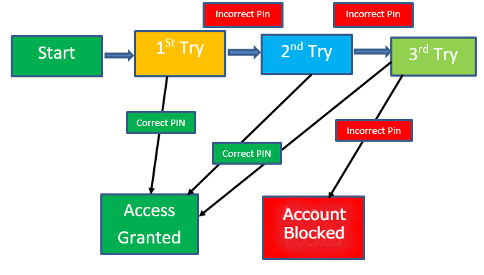

1. **Error Guessing**: A function of the application requires a mobile number which must be of 10 characters. Now, below are the techniques that can be applied to guess error in the mobile number field:

* What will be the result, if the entered character is other than a number?
* What will be the result, if entered characters are less than 10 digits?
* What will be the result, if the mobile field is left blank?

After implementing these techniques, if the output is similar to the expected result, the function is considered to be bug-free, but if the output is not similar to the expected result, so it is sent to the development team to fix the defects.